Embedded Systems Development from the Ground Up

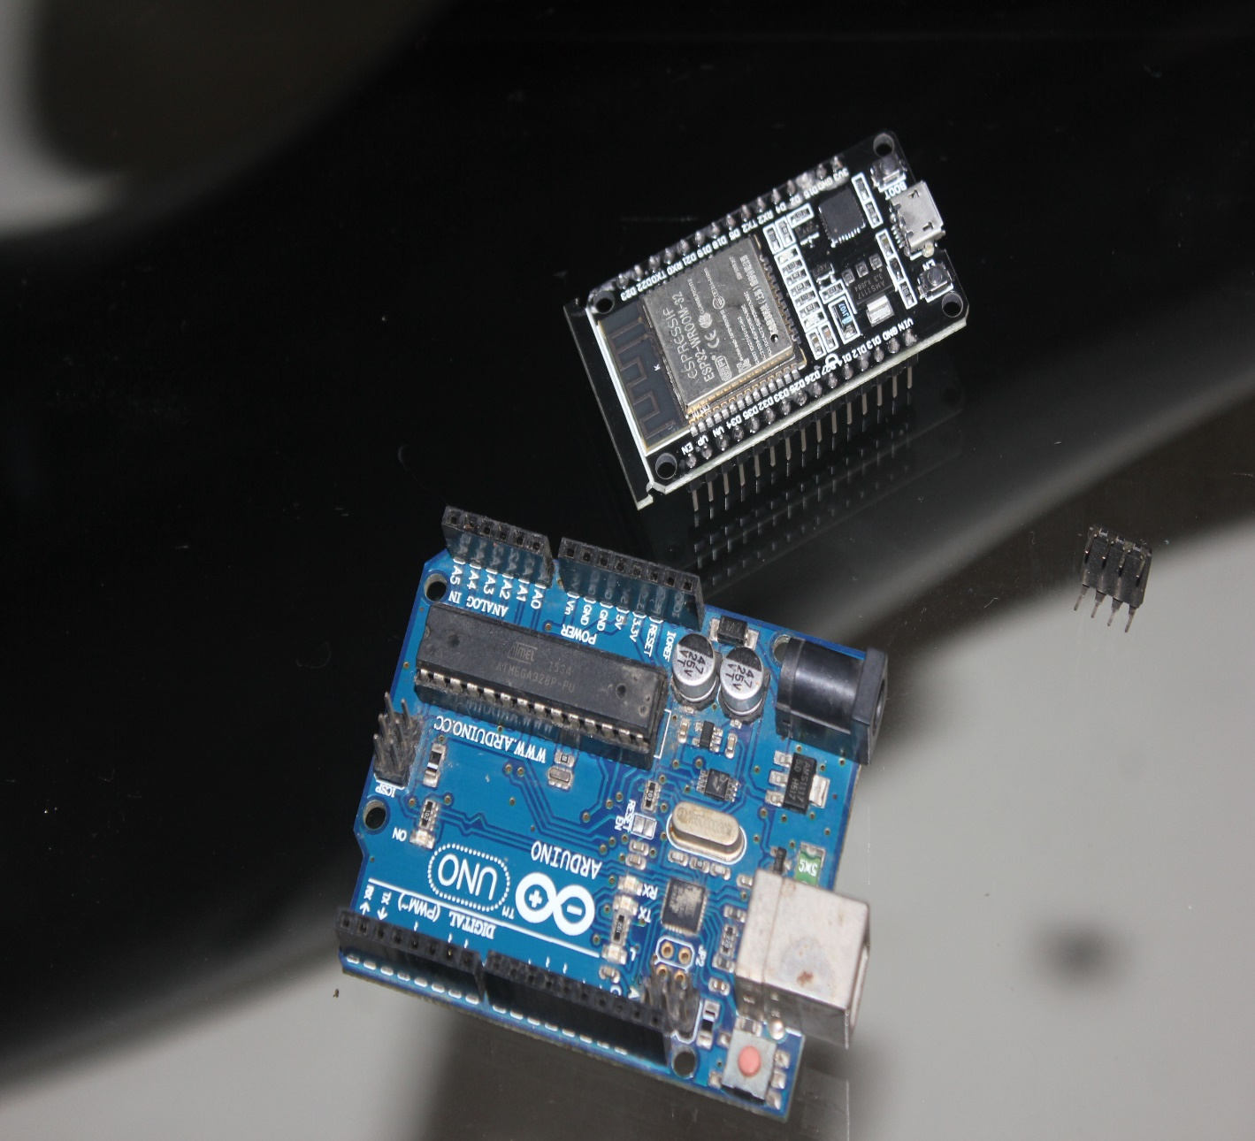

**Santhosh Jayarajan**

**Welcome to the wonderful world of Microcontroller Development. It is exciting but can become overwhelming due to the numerous options that are available.**

**This book is divided into 3 parts:**

* **Part-1 deals with the smallest microcontroller which is small but powerful the ATTiny 85. This “Little Giant” is good for small and quick projects. The project in this part is My Magic Lamp which is a LED Night Lamp with a Android interface to control, set brightness and schedule the lamps operation. Learn also how to use the App Inventor to develop a powerful mobile phone app as interface.**
* **Part-2 moves up a notch to the Arduino platform with Arduino UNO and introduces the use of Python as a programming language to interface with the Arduino. The project in this part uses Python and the Matplotlib to display beautiful real time graphs of Analog Data from the Arduino UNO.**
* **Part-3 moves paces ahead with the ESP-32 and Micro Python and introduces the Wi-Fi capability of the ESP-32 and displaying real time data on a web page.**

**The project for this part is a Web based Weather Station that will use the ESP-32 as measure temperature and humidity and display it real time on a web page.**

**This book uses an easy pace to cover these 3 levels of microcontroller development.**

**This book is not a detailed book on Python but shows you all the tools you need to get started on the next great microcontroller project.**

**All code for the projects are available on GitHub.**

